Acing your Personal Statement!
Description
Get prepared for writing your Personal Statement with the help of our guides, wider reading materials and statement writing tool.

For this session, you’ll need the following Unifrog tools:
- Know-how library guides
- Subjects library
- Personal Statement tool
- Activities/Competencies tool

If, to start with, you are still not sure which subject you want to study, use the following to give you inspiration:
- Personality quiz
- Careers library
- Subject library

Why do this?
Completing these tasks will make sure you’re well on your way to acing your Personal Statement, ready for those all-important UCAS applications!

Task 1:
Start with the basics. If you know which topic you would like to study, go to the Subjects library first. This will give you a great starting point in writing a winning personal statement.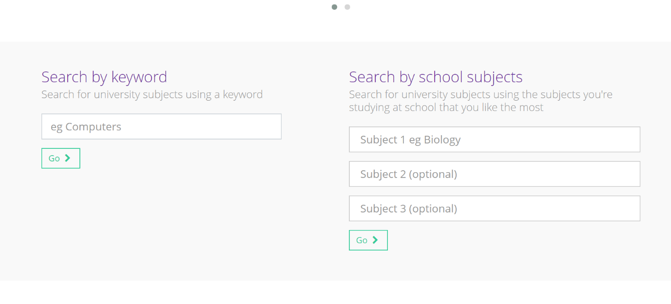
There are over 50,000 undergraduate courses, so make sure to research all the topic areas and similar subjects around your interests. Below is an example of what you’d see if you search for ‘Business’:
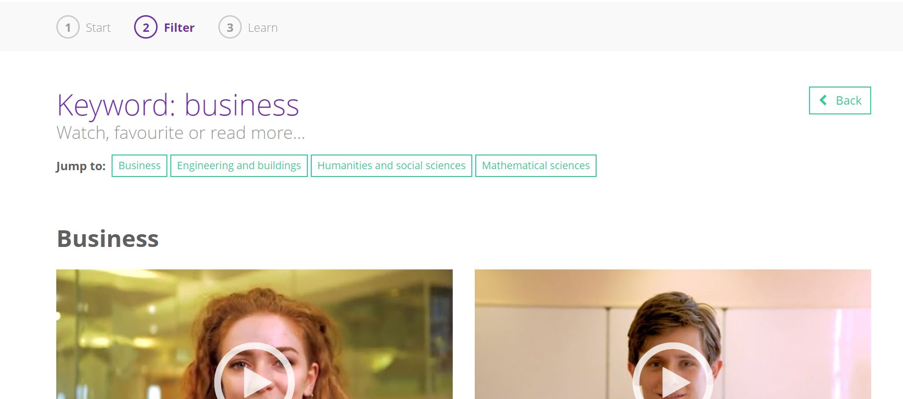

Then select the subject that you would like to study, and you will see a profile that looks like this:
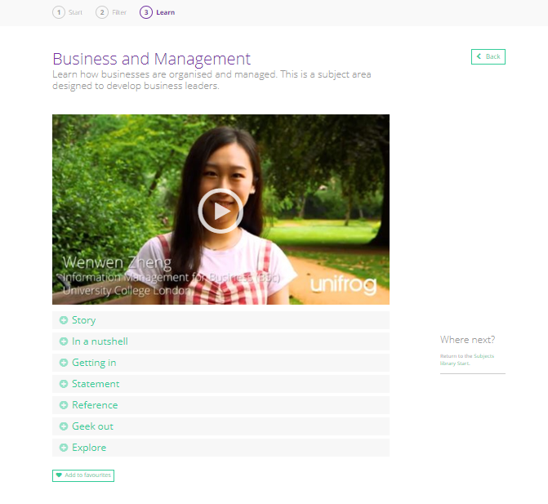

This subject profile will give you a good understanding of everything you need for your Personal Statement, especially our Geek Out section! Let’s start by using this to complete the table below. This could either be a ‘To-Do’ list for you, or ‘Done List’:
Type of activity | Considerations | Evidence
Group work example | What group academic work can I use to show I work well with others?
Independent work example | What independent academic project have I undertaken related to my degree subject?
Wider reading | What have I studied outside of the classroom that shows I have a passion for this subject?
MOOC | Which MOOC did I find relates to my subject area and what did I learn from it?
Competencies | What are the key skills that I need to succeed at this subject? What examples do I have that show I have these skills?
Extracurricular Activities | What activities have I done that are relevant for this subject, e.g. work experience, volunteering, clubs, societies?

Task 2:
After completing your table, go to the Activities and Competencies tools to write about your examples. You may find there are gaps and that you need to set tasks to complete over the summer. Start with the Activities:
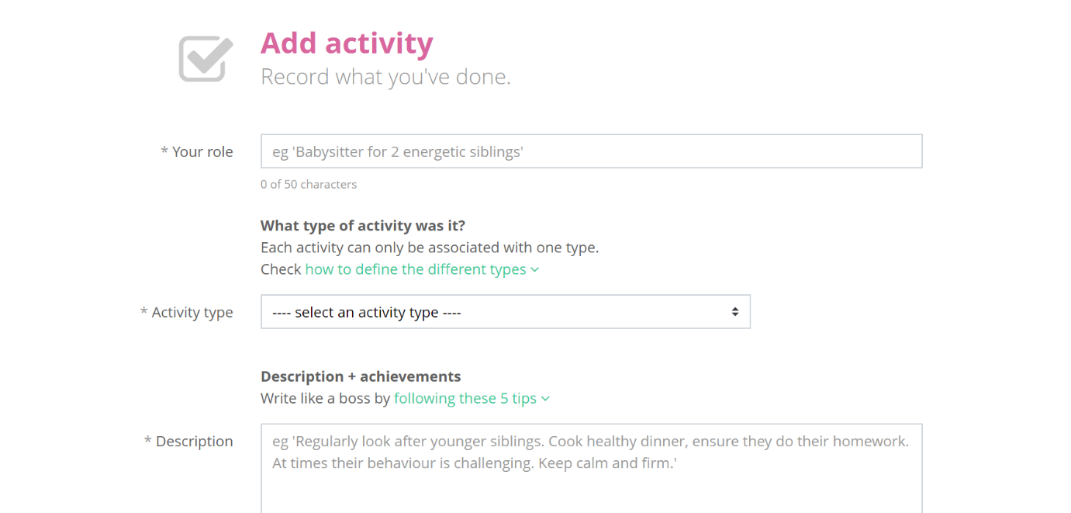
After writing your role, select the activity type. When describing what you did, use these five tips:
- Emphasise the tangible, measurable impact of what you did
- Be specific
- Use the present tense if it is something you still do
- For each activity include any responsibilities you had
- Explain the significance of the activity
Writing in this way is good practice for when you start your Personal Statement. Read what you have written and try to reduce the amount of words you have used to say something. The skill in any writing activity is to draft, and redraft, so that you revise your text to say exactly what you want, nothing more.
Task 2 continued…
Now let’s add some Competencies to evidence your skill set:

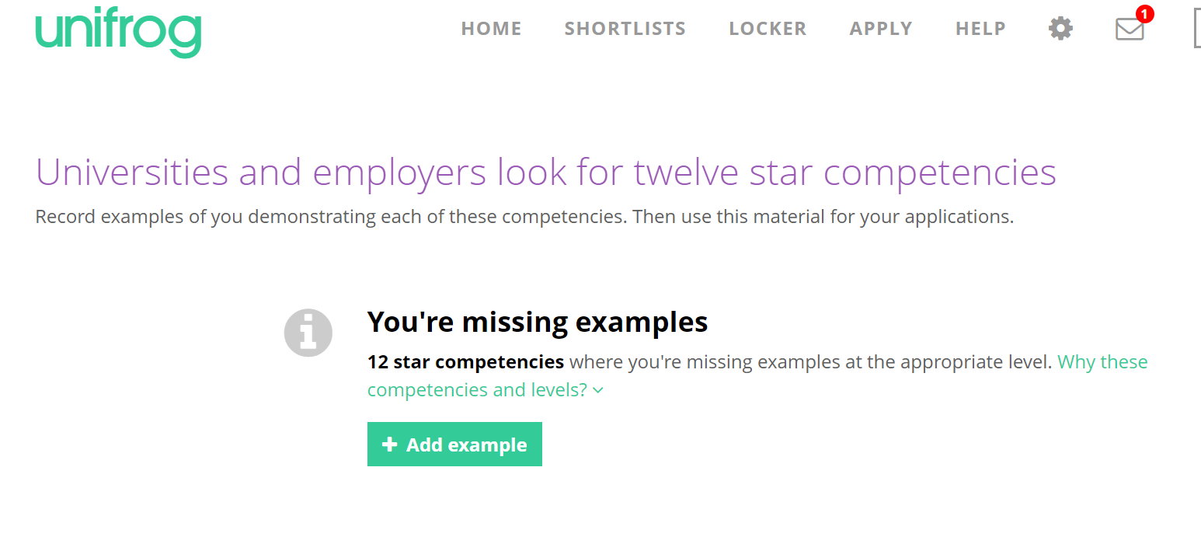
Think about the key competencies mentioned in the Subjects library. What skills do you already have examples for? Try to use the STAR method for writing about skills:
- Situation
- Task
- Action
- Result
Each bullet shouldn’t need more than two sentences, one if possible. Always refer to a specific situation when talking about a skill and don’t generalise. Again, when writing, stick to the point, be specific, and redraft afterward to revise the text.

Task 3:
You should now almost be ready to start your Personal Statement in Unifrog, after completing most of your Personal Statement Prep To-Do-List. Before you do, read through the relevant information in the Know-How Library. In the keyword search type in ‘personal statement’.
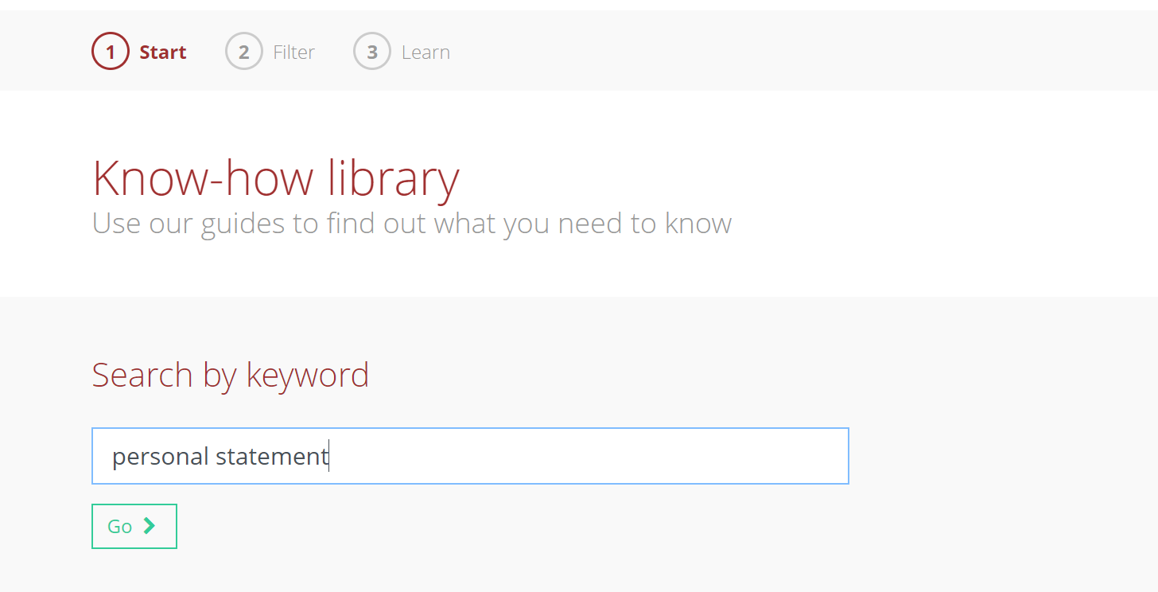
Look for the article, “Writing like a boss: the Personal Statement”.
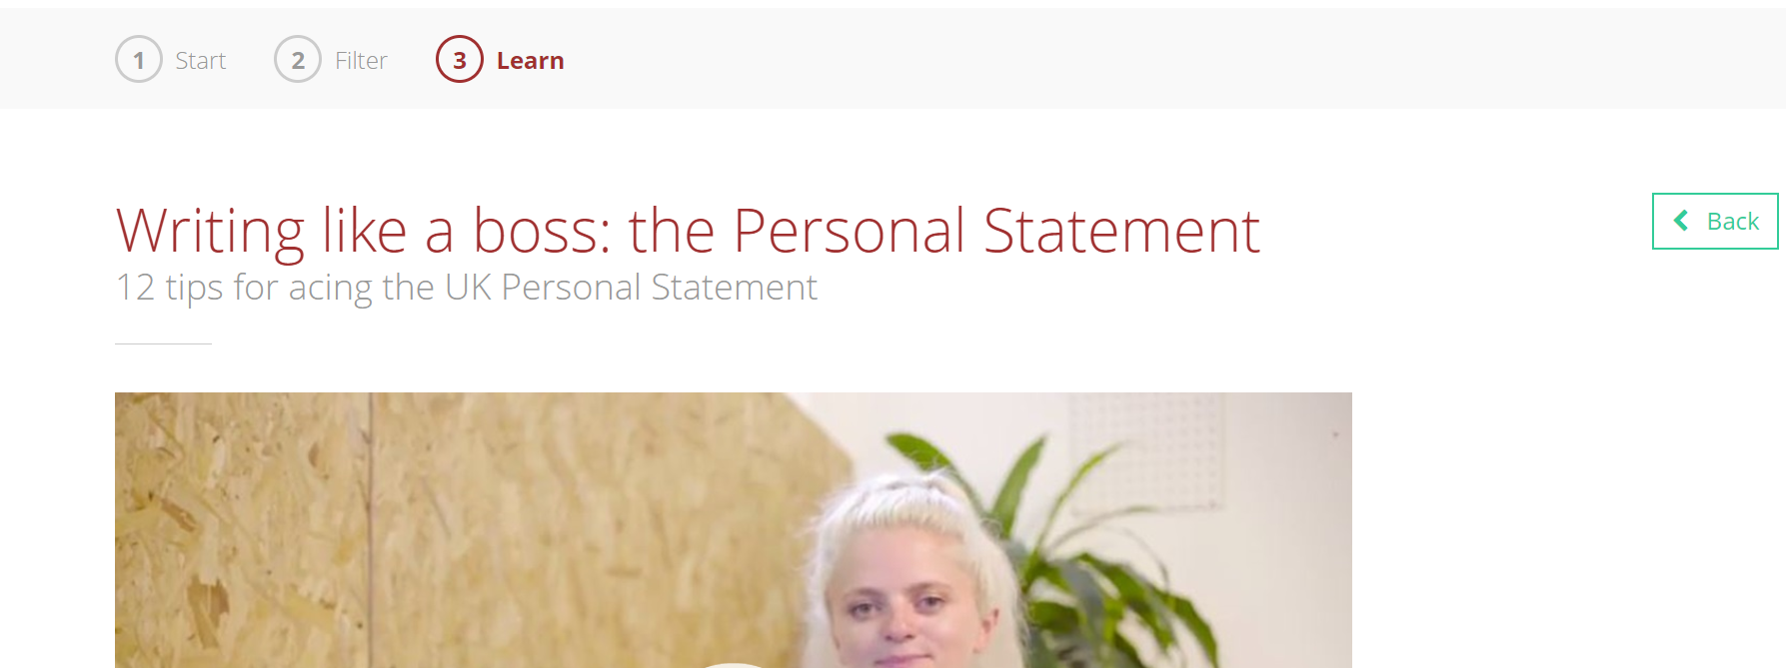
Watch the video and read the guidance. There is a lot to take in, so favourite the video and refer to it as often as needed.
There is also lots of guidance in the Know-how library on Oxbridge, wider-reading, MOOCs, and other topics relevant to university applications.

Task 4:
You’re now ready to go and start your Personal Statement. Even if you are undecided on the exact subject, you can still make a start on some aspects of it. If you have chosen a subject to apply for, write it in the ADD SUBJECT box.
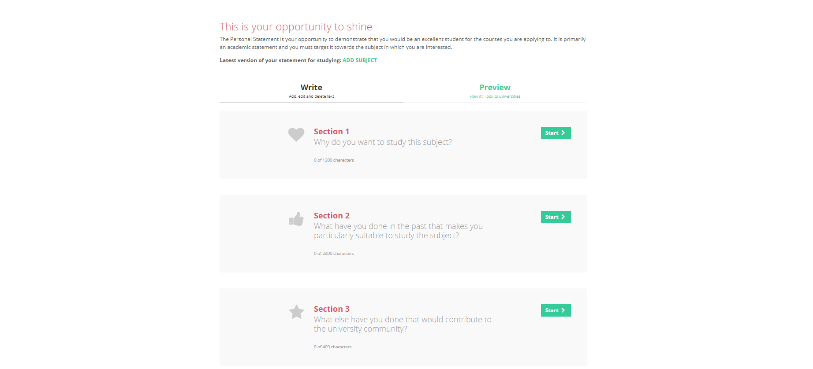
You will notice that there is guidance in each section on how to write in line with the focus for that part. The Personal Statement builder saves the text as you write it and character counts as you type. Don’t worry if you exceed the 4000-character count in your first draft as this is recommended. Remember, ‘draft, redraft’. Redraft and revise until you are happy with it and use the example Personal Statements in the subject library as a guide only. Don’t be tempted to plagiarise!
You can change the Personal Statement builder from three sections to a single box layout. If you have already started to write your Personal Statement elsewhere, Copy and paste it into the builder. Your teachers can automatically see your statement and give you guidance quicker if it is in Unifrog.

