Courses, Universities and entry requirements
Description

For this session, you’ll need the following Unifrog tools:
- UK Universities (Searching for opportunities)
- How to video

If, to start with, you are still not sure which subject you want to study, use the following to give you inspiration:
- Personality quiz
- Careers library
- Subject library

Why do this?

- Strategic choices and unique insights
A uniquely comprehensive live feed of every undergraduate course in the UK.
- Enhanced research
Significantly speeds-up and supports your research, allowing a direct comparison on courses on 25+factors.
- Expectations met
Unique filtering and ranking facilities enabling you to focus on key areas of interest.

Task 1:
Watch the following how to video https://youtu.be/MPwlS2_8NOc

Task 2:
Now it’s your turn. Complete a search and try using the different filters available. Create a shortlist of courses you are interested in. The Shortlist has lots more detailed information so make sure you scroll down to see it all. See below for example.
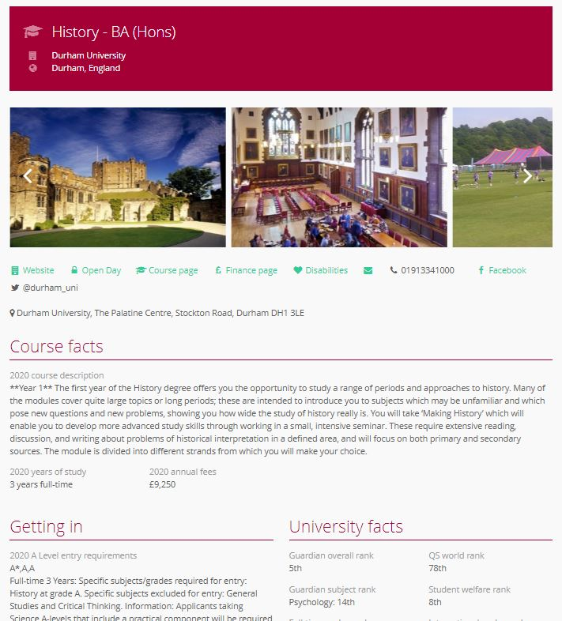
Remember you can make as many Shortlists as you like, and can view them any time by clicking on the Shortlist button on the main dashboard.

