Careers research

Description
Research and create a next steps plan for your potential career pathways.
For this session you will need to use the following Unifrog tools:
- Careers library
- Locker

If, to start with, you are still not sure which career would suit you, use the following to give you inspiration:
- Personality quiz
- Interests Profile

Why do this?
It’s important to research a whole host of different career paths. There are thousands available, so do the research to make sure you’re not limiting your options.

Task 1:
Log into Unifrog and go to the Careers library.

You can search by Keyword or other methods to find your ideal industry. Have a look at related roles and list the 5 most interesting or unusual below. Once you’ve completed it, upload it to your Locker.
1.

2.

3.

4.

5.

Task 2:

Now you’ve narrowed down your options, you need to develop your understanding of what skills and qualifications are needed, and what you’d do on a day to day basis.
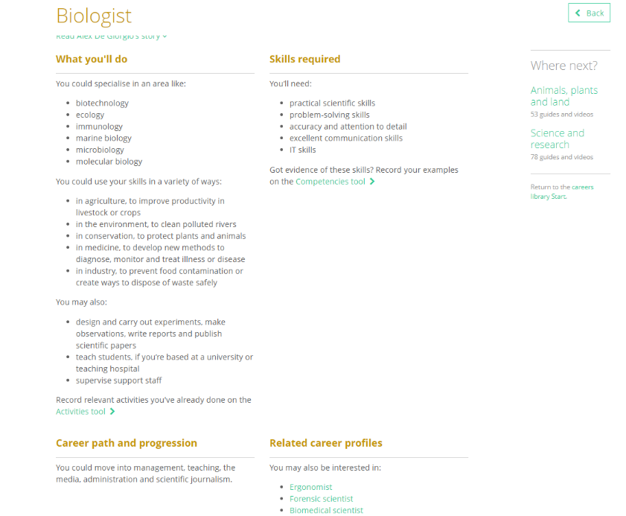

Use the Careers library to complete the table below:

Unifrog tip: Don’t forget to upload this to your Locker!

Career title | What you’ll do | Competencies/skills | UK entry requirements | Working hours, environment and salary

Task 3:
Using all of the information above, choose the career that you think would be best suited to you, and write a short analysis on the reasons why.

Unifrog tip: You’ve guessed it, upload it to your Locker so you can refer back to this later.

If you were going for that role in the future, which goals would you need to set in the short and medium term?
- Goals for the short/medium term (the next few months):

- Goals for the longer term (the next few years):

